Descriptive Statistics:
Term | Meaning | Population Formula | Sample Formula | Example {1,16,1,3,9}
Sort | Sort values in increasing order |  |  | {1,1,3,9,16}
Mean | Average | 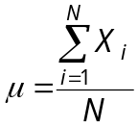 | 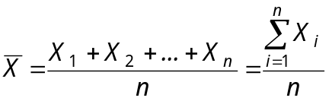 | 6
Median | The middle value – half are below and half are above |  |  | 3
Mode | The value with the most appearances |  |  | 1
Variance | The average of the squared deviations between the values and the mean | 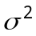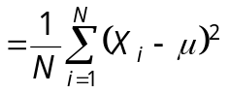 | 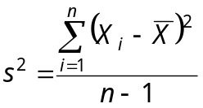 | (1-6)² + (1-6) ² + (3-6)² + (9-6)² + (16-6)² divided by 5 values = 168/5 = 33.6
Standard Deviation | The square root of Variance, thought of as the “average” deviation from the mean. | 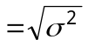 | 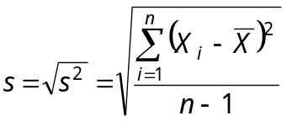 | Square root of 33.6 = 5.7966
Coefficient of Variation | The variation relative to the value of the mean |  | 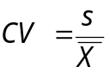 | 5.7966 divided by 6 = 0.9661
Minimum | The minimum value |  |  | 1
Maximum | The maximum value |  |  | 16
Range | Maximum minus Minimum |  |  | 16 – 1 = 15

Probability Terms:
Term | Meaning | Notation | Example* (see footnote)
Probability | For any event A, probability is represented within 0 ≤ P ≤1. | P() | 0.5
Random Experiment | A process leading to at least 2 possible outcomes with uncertainty as to which will occur. |  | Rolling a dice
Event | A subset of all possible outcomes of an experiment. |  | Events A and B
Intersection of Events | Let A and B be two events. Then the intersection of the two events is the event that both A and B occur (logical AND). | A∩B | The event that a 2 appears
Union of Events | The union of the two events is the event that A or B (or both) occurs (logical OR). | A∪B | The event that a 1, 2, 4, 5 or 6 appears
Complement | Let A be an event. The complement of A is the event that A does not occur (logical NOT). | 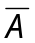 | The event that an odd number appears
Mutually Exclusive Events | A and B are said to be mutually exclusive if at most one of the events A and B can occur. |  | A and B are not mutually exclusive because if a 2 appears, both A and B occur
Collectively Exhaustive Events | A and B are said to be collectively exhaustive if at least one of the events A or B must occur. |  | A and B are not collectively exhaustive because if a 3 appears, neither A nor B occur
Basic Outcomes | The simple indecomposable possible results of an experiment. One and exactly one of these outcomes must occur. The set of basic outcomes is mutually exclusive and collectively exhaustive. |  | Basic outcomes 1, 2, 3, 4, 5, and 6
Sample Space | The totality of basic outcomes of an experiment. |  | {1,2,3,4,5,6}
* Roll a fair die once. Let A be the event an even number appears, let B be the event a 1, 2 or 5 appears
Probability Rules:
If events A and B are mutually exclusive |  |  |  | If events A and B are NOT mutually exclusive
Term | Equals | Area:  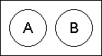 |  | Term | Equals | Venn:  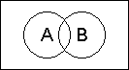 | 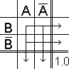
P(A)= | P(A) | 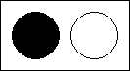 |  | P(A)= | P(A) | 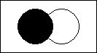 | 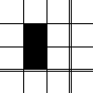
P()= | 1 - P(A) |  |  | P()= | 1 - P(A) |  | 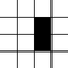
P(A∩B)= | 0 | 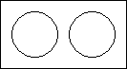 |  | P(A∩B)= | P(A) * P(B)  only if A and B are independent | 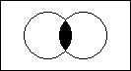 | 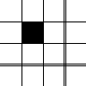
P(A∪B)= | P(A) + P(B) |  |  | P(A∪B)= | P(A) + P(B) – P(A∩B) |  | 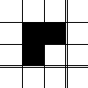
 |  |  |  | P(A|B)=  [Bayes' Law: P(A holds given that B holds)] | 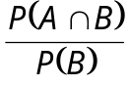 | ÷  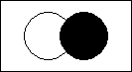 | ÷  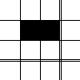
General probability rules:

1) If P(A|B) = P(A), then A and B are independent events! (for example, rolling dice one after the other).

2) If there are n possible outcomes which are equally likely to occur:
P(outcome i occurs) = for each i ∈ [1, 2, ..., n]

*Example: Shuffle a deck of cards, and pick one at random. P(chosen card is a 10♦) = 1/52.

3) If event A is composed of n equally likely basic outcomes:
P(A) =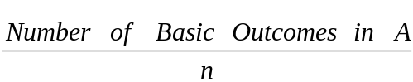

*Example: Suppose we toss two dice. Let A denote the event that the sum of the two dice is 9. P(A) = 4/36 = 1/9, because there are 4 out of 36 basic outcomes that will sum 9.
 |  |  |  | P(A∩B) = P(A|B) * P(B)
 |  |  |  | P(A∩B) = P(B|A) * P(A)
 |  |  |  | P(A)= | P(A∩B) + P(A∩)  =  P(A|B)P(B) + P(A|)P( ) | +  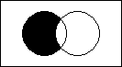 | +  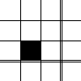
 |  |  |  | *Example: Take a deck of 52 cards. Take out 2 cards sequentially, but don’t look at the first. The probability that the second card you chose was a ♣ is the probability of choosing a ♣ (event A) after choosing a ♣ (event B), plus the probability of choosing a ♣ (event A) after not choosing a ♣ (event B), which equals (12/51)(13/52) + (13/51)(39/52) = 1/4 = 0.25.
Random Variables and Distributions:
To calculate the Expected Value 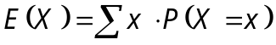, use the following table:
∇ * ∇ = ∇
Event | Payoff | Probability | Weighted Payoff
[name of first event] | [payoff of first event in $] | [probability of first event 0≤P≤1] | [product of Payoff * Probability]
[name of second event] | [payoff of second event in $] | [probability of second event 0≤P≤1] | [product of Payoff * Probability]
[name of third event] | [payoff of third event in $] | [probability of third event 0≤P≤1] | [product of Payoff * Probability]
* See example in BOOK 1 page 54 |  | Total (Expected Payoff): | [total of all Weighted Payoffs above]

To calculate the Variance Var(X) =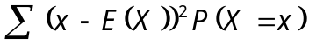 and Standard Deviation 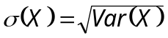, use:
∇ - ∇ = ∇ ^2= ∇ * ∇ = ∇
Event | Payoff | Expected Payoff | Error | (Error)² | Probability | Weighted (Error)²
[1st event] | [1st payoff] | [Total from above] | [1st payoff minus Expected Payoff] | 1st Error squared | 1st event’s probability | 1st (Error)² * 1st event’s probability
[2nd event] | [2nd payoff] | [Total from above] | [2nd payoff minus Expected Payoff] | 2nd Error squared | 2nd event’s probability | 2nd (Error)² * 2nd event’s probability
[3rd event] | [3rd payoff] | [Total from above] | [3rd payoff minus Expected Payoff] | 3rd Error squared | 3rd event’s probability | 3rd (Error)² * 3rd event’s probability
 |  |  |  |  | Variance: | [total of above]
 |  |  |  |  | Std. Deviation: | [square root of Variance]
Counting Rules:
Term | Meaning | Formula | Example
Basic Counting Rule | The number of ways to pick x things out of a set of n (with no regard to order). The probability is calculated as 1/x of the result. | 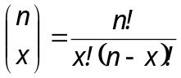 | The number of ways to pick 4 specific cards out of a deck of 52 is: 52!/((4!)(48!)) = 270,725, and the probability is 1/270,725 = 0.000003694
Bernoulli Process | For a sequence of n trials, each with an outcome of either success or failure, each with a probability of p to succeed – the probability to get x successes is equal to the Basic Counting Rule formula (above) times p^{x}(1-p)^{n-x}. | 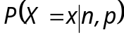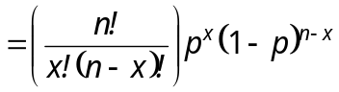 | If an airline takes 20 reservations, and there is a 0.9 probability that each passenger will show up, then the probability that exactly 16 passengers will show is:  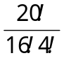 (0.9)¹⁶(0.1)⁴  = 0.08978
Bernoulli Expected Value | The expected value of a Bernoulli Process, given n trials and p probability. | E(X) = np | In the example above, the number of people expected to show is: (20)(0.9) = 18
Bernoulli Variance | The variance of a Bernoulli Process, given n trials and p probability. | Var(X) = np(1 - p) | In the example above, the Bernoulli Variance is (20)(0.9)(0.1) = 1.8
Bernoulli Standard Deviation | The standard deviation of a Bernoulli Process: | σ(X) = 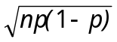 | In the example above, the Bernoulli Standard Deviation is 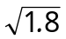= 1.34
Linear Transformation Rule | If X is random and Y=aX+b, then the following formulas apply: | E(Y) = a*E(X) + b  Var (Y) = a²*Var(X)  σ (Y) = |a|*σ(X)

Uniform Distribution:
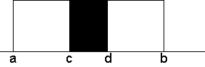 | Term/Meaning | Formula
 | Expected Value | 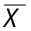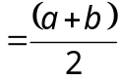
 | Variance | 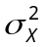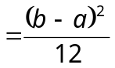
 | Standard Deviation | 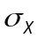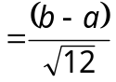
 | Probability that X falls between c and d | 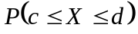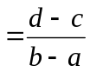

Normal Distribution:
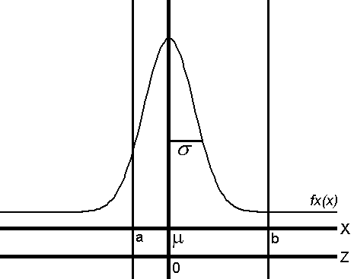 |  | z | 0.00 | 0.01 | 0.02 | 0.03 | 0.04 | 0.05 | 0.06 | 0.07 | 0.08 | 0.09
 |  | 0.0 | .0000 | .0040 | .0080 | .0120 | .0160 | .0199 | .0239 | .0279 | .0319 | .0359
 |  | 0.1 | .0398 | .0438 | .0478 | .0517 | .0557 | .0596 | .0636 | .0675 | .0714 | .0753
 |  | 0.2 | .0793 | .0832 | .0871 | .0910 | .0948 | .0987 | .1026 | .1064 | .1103 | .1141
 |  | 0.3 | .1179 | .1217 | .1255 | .1293 | .1331 | .1368 | .1406 | .1443 | .1480 | .1517
 |  | 0.4 | .1554 | .1591 | .1628 | .1664 | .1700 | .1736 | .1772 | .1808 | .1844 | .1879
 |  | 0.5 | .1915 | .1950 | .1985 | .2019 | .2054 | .2088 | .2123 | .2157 | .2190 | .2224
 |  | 0.6 | .2257 | .2291 | .2324 | .2357 | .2389 | .2422 | .2454 | .2486 | .2517 | .2549
 |  | 0.7 | .2580 | .2611 | .2642 | .2673 | .2704 | .2734 | .2764 | .2794 | .2823 | .2852
 |  | 0.8 | .2881 | .2910 | .2939 | .2967 | .2995 | .3023 | .3051 | .3078 | .3106 | .3133
Probability Density Function:  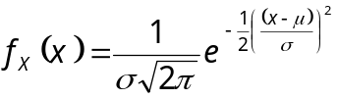  where π ≅ 3.1416 and e ≅ 2.7183 |  | 0.9 | .3159 | .3186 | .3212 | .3238 | .3264 | .3289 | .3315 | .3340 | .3365 | .3389
 |  | 1.0 | .3413 | .3438 | .3461 | .3485 | .3508 | .3531 | .3554 | .3577 | .3599 | .3621
 |  | 1.1 | .3643 | .3665 | .3686 | .3708 | .3729 | .3749 | .3770 | .3790 | .3810 | .3830
 |  | 1.2 | .3849 | .3869 | .3888 | .3907 | .3925 | .3944 | .3962 | .3980 | .3997 | .4015
 |  | 1.3 | .4032 | .4049 | .4066 | .4082 | .4099 | .4115 | .4131 | .4147 | .4162 | .4177
Standard Deviations away from the mean:  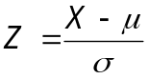  (Z and σ are swappable!) |  | 1.4 | .4192 | .4207 | .4222 | .4236 | .4251 | .4265 | .4279 | .4292 | .4306 | .4319
 |  | 1.5 | .4332 | .4345 | .4357 | .4370 | .4382 | .4394 | .4406 | .4418 | .4429 | .4441
 |  | 1.6 | .4452 | .4463 | .4474 | .4484 | .4495 | .4505 | .4515 | .4525 | .4535 | .4545
 |  | 1.7 | .4554 | .4564 | .4573 | .4582 | .4591 | .4599 | .4608 | .4616 | .4625 | .4633
P(a ≤ X ≤ b) = area under f_{X}(x) between a and b:  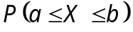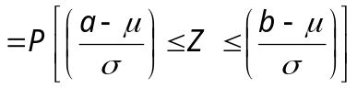 |  | 1.8 | .4641 | .4649 | .4656 | .4664 | .4671 | .4678 | .4686 | .4693 | .4699 | .4706
 |  | 1.9 | .4713 | .4719 | .4726 | .4732 | .4738 | .4744 | .4750 | .4756 | .4761 | .4767
 |  | 2.0 | .4772 | .4778 | .4783 | .4788 | .4793 | .4798 | .4803 | .4808 | .4812 | .4817
 |  | 2.1 | .4821 | .4826 | .4830 | .4834 | .4838 | .4842 | .4846 | .4850 | .4854 | .4857
Standard Normal Table - seven usage scenarios: |  | 2.2 | .4861 | .4864 | .4868 | .4871 | .4875 | .4878 | .4881 | .4884 | .4887 | .4890
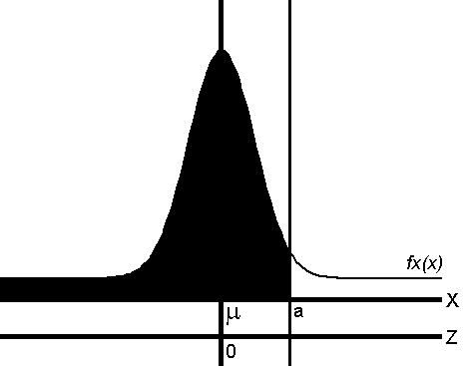 = 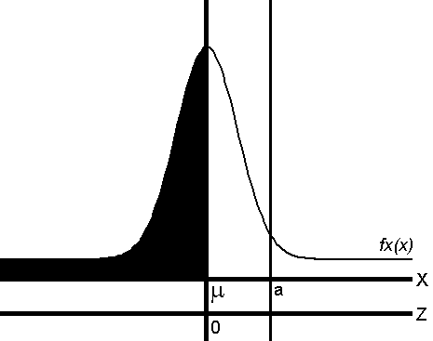 + 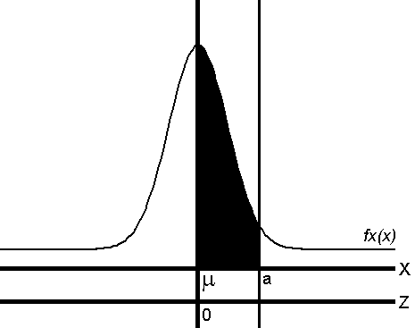 | 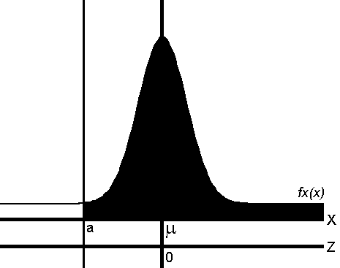 = 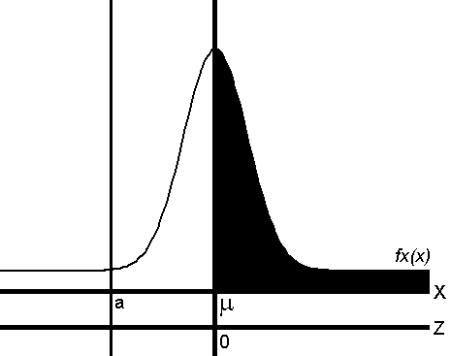 + 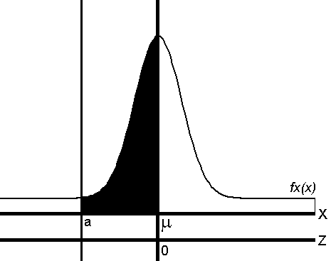 | 2.3 | .4893 | .4896 | .4898 | .4901 | .4904 | .4906 | .4909 | .4911 | .4913 | .4916
 |  | 2.4 | .4918 | .4920 | .4922 | .4925 | .4927 | .4929 | .4931 | .4932 | .4934 | .4936
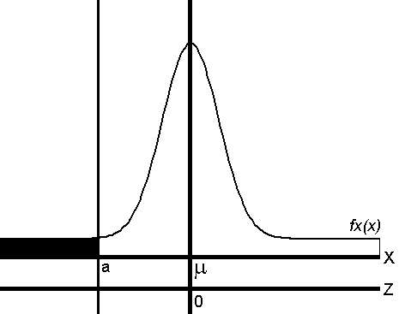 = 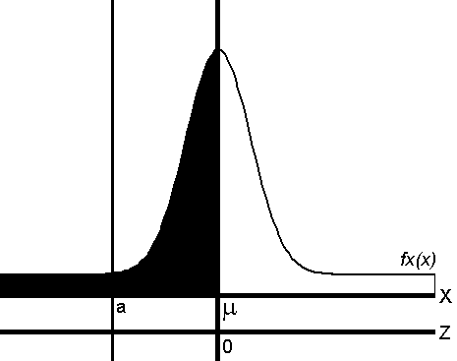 - | 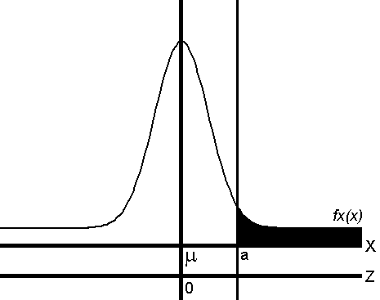 = 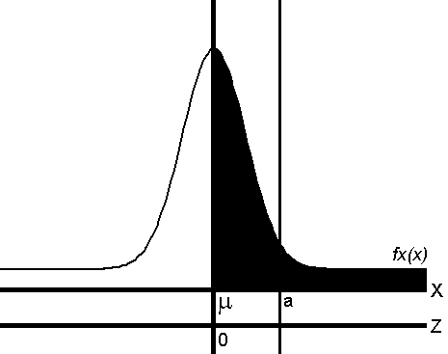 - 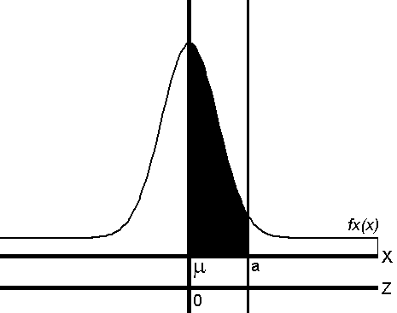 | 2.5 | .4938 | .4940 | .4941 | .4943 | .4945 | .4946 | .4948 | .4949 | .4951 | .4952
 |  | 2.6 | .4953 | .4955 | .4956 | .4957 | .4959 | .4960 | .4961 | .4962 | .4963 | .4964
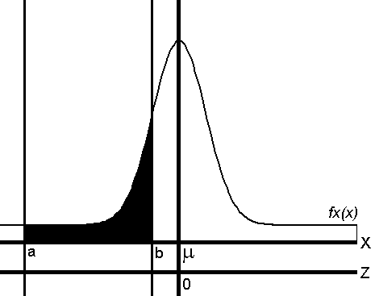 = 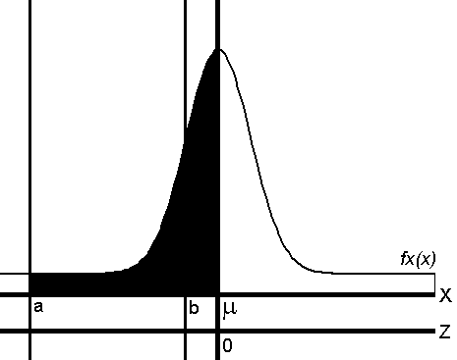 - 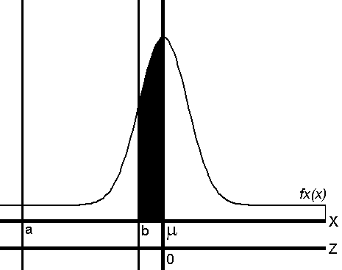 | 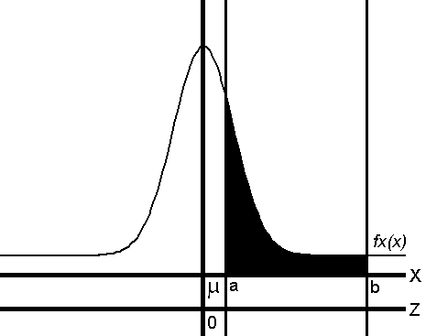 = 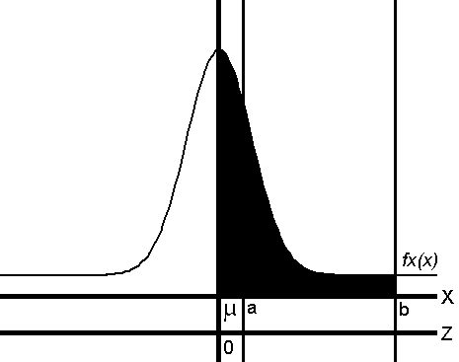 - 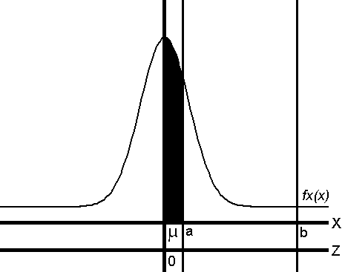 | 2.7 | .4965 | .4966 | .4967 | .4968 | .4969 | .4970 | .4971 | .4972 | .4973 | .4974
 |  | 2.8 | .4974 | .4975 | .4976 | .4977 | .4977 | .4978 | .4979 | .4979 | .4980 | .4981
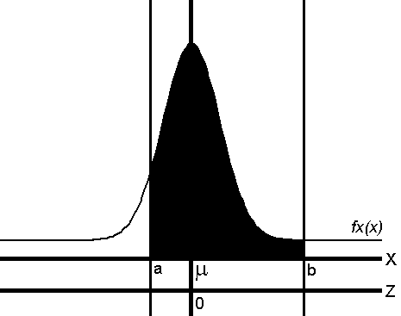 = 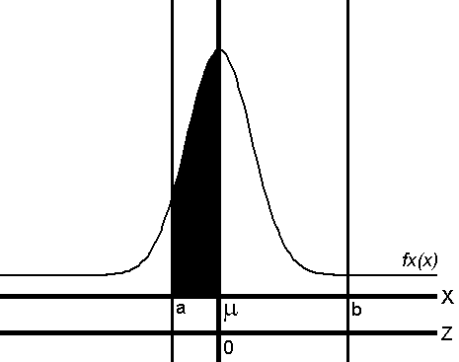 + 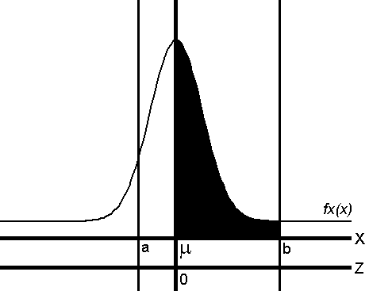 |  | 2.9 | .4981 | .4982 | .4982 | .4983 | .4984 | .4984 | .4985 | .4985 | .4986 | .4986
 |  | 3.0 | .4987 | .4987 | .4987 | .4988 | .4988 | .4989 | .4989 | .4989 | .4990 | .4990
Correlation:
- If X and Y are two different sets of data, their correlation is represented by Corr_{(XY)}, r_{XY}, or ρ_{XY} (rho).
- If Y increases as X increases, 0 < ρ _{XY} < 1. If Y decreases as X increases, -1 < ρ _{XY} < 0.
- The extremes ρ _{XY} = 1 and ρ _{XY} = -1 indicated perfect correlation – info about one results in an exact prediction about the other.
- If X and Y are completely uncorrelated, ρ_{XY} = 0.
- The Covariance of X and Y, Cov_{(XY)} , has the same sign as ρ _{XY}, has unusual units and is usually a means to find ρ _{XY}.
Term | Formula | Notes
Correlation | 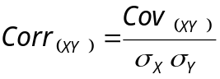 | Used with Covariance formulas below
Covariance (2 formulas) | 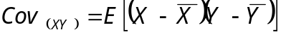  (difficult to calculate) | Sum of the products of all sample pairs’ distance from their respective means multiplied by their respective probabilities
Covariance (2 formulas) | 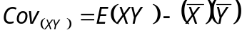 | Sum of the products of all sample pairs multiplied by their respective probabilities, minus the product of both means
Finding Covariance given Correlation | 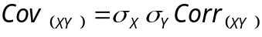

Portfolio Analysis:
 | Term | Formula | Example*
 | Mean of any Portfolio “S” | 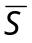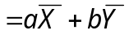 | = ¾(8.0%)+ ¼(11.0%) = 8.75%
Uncorrelated | Portfolio Variance | σ²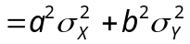 | σ² = (¾)²(0.5)² + (¼)²(6.0)² = 2.3906
Uncorrelated | Portfolio Standard Deviation | σ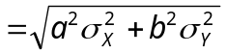 | σ = 1.5462
Correlated | Portfolio Variance | 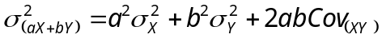
Correlated | Portfolio Standard Deviation | 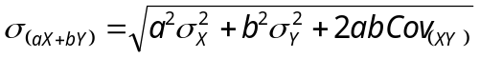
* Portfolio “S” composed of ¾ Stock A (mean return: 8.0%, standard deviation: 0.5%) and ¼ Stock B (11.0%, 6.0% respectively)

The Central Limit Theorem  Normal distribution can be used to approximate binominals of more than 30 trials (n≥30): |  |  | Continuity Correction  Unlike continuous (normal) distributions (i.e. $, time), discrete binomial distribution of integers (i.e. # people) must be corrected:
Term | Formula |  | Old cutoff | New cutoff | 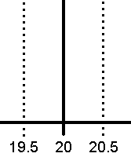
Mean | E(X) = np |  | P(X>20) | P(X>20.5)
Variance | Var(X) = np(1 - p) |  | P(X<20) | P(X<19.5)
Standard Deviation | σ(X) = |  | P(X≥20) | P(X≥19.5)
 |  |  | P(X≤20) | P(X≤20.5)

Sampling Distribution of the Mean  If the X_{i}'s are normally distributed (or n ≥ 30), then  is normally distributed with: |  |  | Sampling Distribution of a Proportion  If, for a proportion, n ≥ 30 then 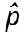 is normally distributed with:
Term | Formula |  | Term | Formula
Mean | μ |  | Mean | p
Standard Error of the Mean | 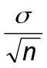 |  | Standard Deviation | 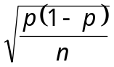

Confidence Intervals:
 | Parameter | Confidence Interval | Usage | Sample | σ
1 |  | 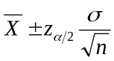 | Normal |  | Known σ
1 |  | 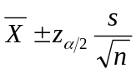 |  | Large | Unknown σ
2 |  | 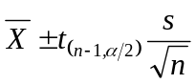 | Normal | Small | Unknown σ
3 |  | 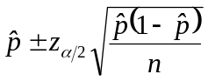 | Binomial | Large
4 | 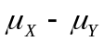 | 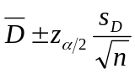 | Normal |  | Matched pairs
5 |  | 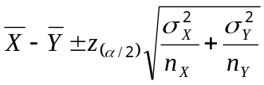 | Normal |  | Known σ,  Independent Samples
5 |  | 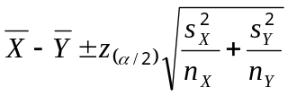 |  | Large
6 | 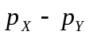 | 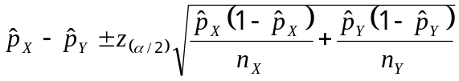 | Binomial | Large

Formulae Guide |  |  |  |  | t-table
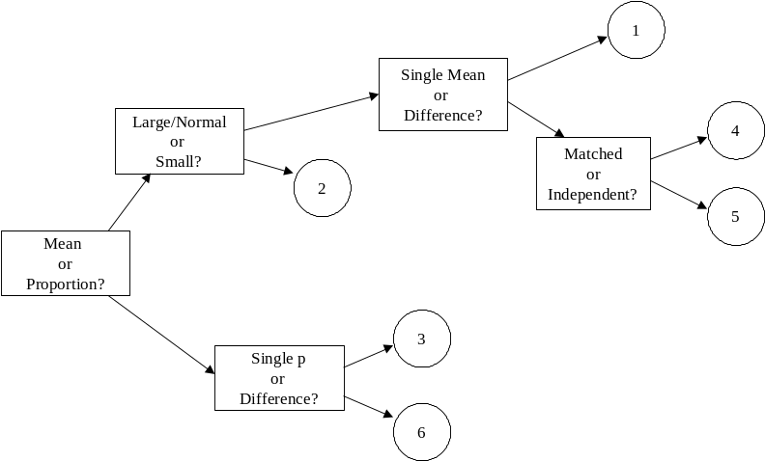 |  |  |  |  | d. f. | 0.100 | 0.050 | 0.025 | 0.010 | 0.005
 |  |  |  |  | 1 | 3.078 | 6.314 | 12.706 | 31.821 | 63.656
 |  |  |  |  | 2 | 1.886 | 2.920 | 4.303 | 6.965 | 9.925
 |  |  |  |  | 3 | 1.638 | 2.353 | 3.182 | 4.541 | 5.841
 |  |  |  |  | 4 | 1.533 | 2.132 | 2.776 | 3.747 | 4.604
 |  |  |  |  | 5 | 1.476 | 2.015 | 2.571 | 3.365 | 4.032
 |  |  |  |  | 6 | 1.440 | 1.943 | 2.447 | 3.143 | 3.707
 |  |  |  |  | 7 | 1.415 | 1.895 | 2.365 | 2.998 | 3.499
 |  |  |  |  | 8 | 1.397 | 1.860 | 2.306 | 2.896 | 3.355
 |  |  |  |  | 9 | 1.383 | 1.833 | 2.262 | 2.821 | 3.250
 |  |  |  |  | 10 | 1.372 | 1.812 | 2.228 | 2.764 | 3.169
 |  |  |  |  | 11 | 1.363 | 1.796 | 2.201 | 2.718 | 3.106
 |  |  |  |  | 12 | 1.356 | 1.782 | 2.179 | 2.681 | 3.055
 |  |  |  |  | 13 | 1.350 | 1.771 | 2.160 | 2.650 | 3.012
 |  |  |  |  | 14 | 1.345 | 1.761 | 2.145 | 2.624 | 2.977
 |  |  |  |  | 15 | 1.341 | 1.753 | 2.131 | 2.602 | 2.947
 |  |  |  |  | 16 | 1.337 | 1.746 | 2.120 | 2.583 | 2.921
Confidence Level to Z-Value Guide |  |  |  |  | 17 | 1.333 | 1.740 | 2.110 | 2.567 | 2.898
Confidence Level |  | Z_{α/2} (2-Tail) | Z_{α} (1-Tail) |  | 18 | 1.330 | 1.734 | 2.101 | 2.552 | 2.878
80% | α = 20% | 1.28 | 0.84 |  | 19 | 1.328 | 1.729 | 2.093 | 2.539 | 2.861
90% | α = 10% | 1.645 | 1.28 |  | 20 | 1.325 | 1.725 | 2.086 | 2.528 | 2.845
95% | α = 5% | 1.96 | 1.645 |  | 21 | 1.323 | 1.721 | 2.080 | 2.518 | 2.831
99% | α = 1% | 2.575 | 2.325 |  | 22 | 1.321 | 1.717 | 2.074 | 2.508 | 2.819
c | α = 1.0-c | Z_{(c/2)} | z_{(c-0.5)} |  | 23 | 1.319 | 1.714 | 2.069 | 2.500 | 2.807
 |  |  |  |  | 24 | 1.318 | 1.711 | 2.064 | 2.492 | 2.797
Determining the Appropriate Sample Size |  |  |  |  | 25 | 1.316 | 1.708 | 2.060 | 2.485 | 2.787
Term |  | Normal Distribution Formula | Proportion Formula |  | 26 | 1.315 | 1.706 | 2.056 | 2.479 | 2.779
Sample Size (for +/- e) |  | 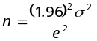 | 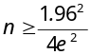 |  | 27 | 1.314 | 1.703 | 2.052 | 2.473 | 2.771
 |  |  |  |  | 28 | 1.313 | 1.701 | 2.048 | 2.467 | 2.763
Hypothesis Testing:
 |  | Two-tailed |  | Lower-tail |  | Upper-tail
Test Type | Test Statistic | H_{a} | Critical Value | H_{a} | Critical Value | H_{a} | Critical Value
Single μ (n ≥ 30) | 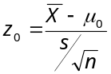 | 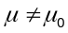 | 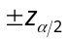 | 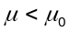 | 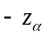 | 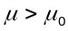 | 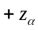
Single μ (n < 30) | 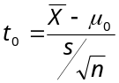 |  | 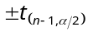 |  | 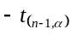 |  | 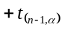
Single p (n ≥ 30) | 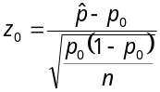 | 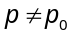 | 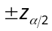 | 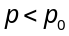 |  | 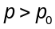
Diff. between two μs | 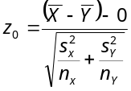 | 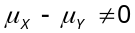 |  | 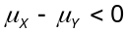 |  | 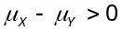
Diff. between two ps | 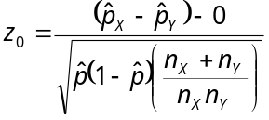 | 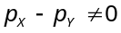 |  | 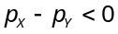 |  | 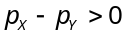

Classic Hypothesis Testing Procedure
Step |  | Description | Example
1 | Formulate Two Hypotheses | The hypotheses ought to be mutually exclusive and collectively exhaustive. The hypothesis to be tested (the null hypothesis) always contains an equals sign, referring to some proposed value of a population parameter. The alternative hypothesis never contains an equals sign, but can be either a one-sided or two-sided inequality. | H₀: μ = 0  H_{A}: μ < 0
2 | Select a Test Statistic | The test statistic is a standardized estimate of the difference between our sample and some hypothesized population parameter. It answers the question: “If the null hypothesis were true, how many standard deviations is our sample away from where we expected it to be?” | 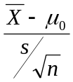
3 | Derive a Decision Rule | The decision rule consists of regions of rejection and non-rejection, defined by critical values of the test statistic. It is used to establish the probable truth or falsity of the null hypothesis. | We reject H₀ if 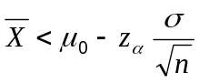.
4 | Calculate the Value of the Test Statistic; Invoke the Decision Rule in light of the Test Statistic | Either reject the null hypothesis (if the test statistic falls into the rejection region) or do not reject the null hypothesis (if the test statistic does not fall into the rejection region. | 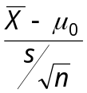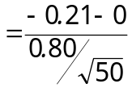

Regression:
Statistic | Symbol |  | Regression Statistics
Independent Variables | X₁,…X_{k} |  | Multiple R | 0.9568
Independent Variables | X₁,…X_{k} |  | R Square | 0.9155
Dependent Variable (a random variable) | Y |  | Adjusted R Square | 0.9015
Dependent Variable (a random variable) | Y |  | Standard Error | 6.6220
Dependent Variable (an individual observation among sample) | Y_{i} |  | Observations | 15
Dependent Variable (an individual observation among sample) | Y_{i} |  | ANOVA
Intercept (or constant); an unknown population parameter | 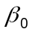 |  |  | df | SS | MS | F | Significance F
Intercept (or constant); an unknown population parameter |  |  | Regression | 2 | 5704.0273 | 2852.0137 | 65.0391 | 0.0000
Estimated intercept; an estimate of | 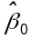 |  | Residual | 12 | 526.2087 | 43.8507
 |  |  | Total | 14 | 6230.2360
Slope (or coefficient) for Independent Variable 1 (unknown) | 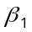 |  |  | Coefficients | Standard Error | t Stat | P-value
Slope (or coefficient) for Independent Variable 1 (unknown) |  |  | Intercept | -20.3722 | 9.8139 | -2.0758 | 0.0601
Estimated slope for Independent Variable 1; an estimate of | 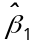 |  | Size (100 sq ft) | 4.3117 | 0.4104 | 10.5059 | 0.0000
 |  |  | Lot Size (1000 sq ft) | 4.7177 | 0.7646 | 6.1705 | 0.0000

Statistic (Mapped to Output Above) | Symbol | Formula |  | Statistic (Mapped to Output Above) | Symbol | Formula
Dependent Variable (sample mean of n observations) | 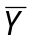 | 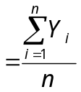 |  | 0.9155  R-square  (Coefficient of Determination) | 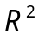 | 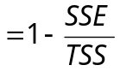
Dependent Variable (estimated value for a given vector of independent variables) | 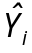 | 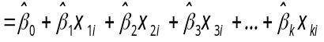 |  | 0.9568  Multiple R  (Coefficient of Multiple Correlation) | 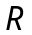 | 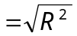
Error for observation i. The unexplained difference between the actual value of Y_{i} and the prediction for Y_{i} based on our regression model. | 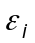 | 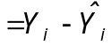 |  | 0.9015  Adjusted R-square | 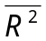 | 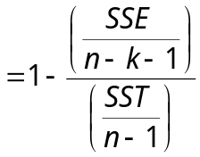
6230.2360  Total Sum of Squares | 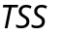  (or SST) | 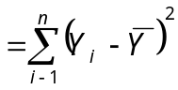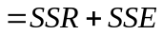 |  | 6.6220  Standard Error (a.k.a. Standard Error of the Estimate) | 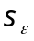 | 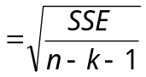
526.2087  Sum of Squares due to Error | 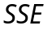 | 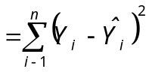 |  | -2.0758  t-statistic for testing 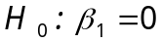vs. 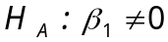 | 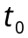 | 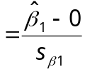
43.8507  Mean Squares due to Error | 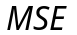 | 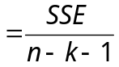 |  | 0.0601  p-value for testing  vs. | p-value | 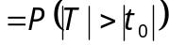
5704.0273  Sum of Squares due to Regression | 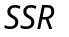 | 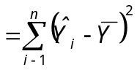 |  | 65.0391  F |  | 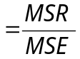
2852.0137  Mean Squares due to Regression | 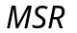 | 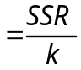 |  |  |  | 